**PHIẾU DUYỆT ĐỒ ÁN TỐT NGHIỆP**

**I. Phần dành cho Sinh viên**

*1. Họ và tên: Lê Anh Tuấn 2. Mã Sinh viên: 102140230 3. Lớp: 14TCLC2*

*4. Tên đề tài: Building the web system connecting football teams*

*5. Số điện thoại: 0378861023 6. E-mail: leanhtuan.it14@gmail.com*

*7. Họ và tên GVHD: Phạm Công Thắng*

**II. Phần dành cho Hội đồng**

|  |  |  |
| --- | --- | --- |
| **STT** | **Nội dung đánh giá** | **Kết luận** |
|  | *Trình bày báo cáo theo đúng mẫu qui định của Khoa* |  |
|  | *Không có sự sao chép nội dung báo cáo và chương trình đã có* |  |
|  | Biên dịch mã nguồn và chạy được chương trình |  |
|  | Có kịch bản thực hiện với dữ liệu thử nghiệm |  |
|  | Kết quả thực hiện chương trình đúng theo báo cáo |  |
|  | Có sự đóng góp, phát triển của tác giả trong đồ án |  |

**Ý kiến khác:** .........................................................................................................................................................................

.............................................................................................................................................................................................................

**Kết luận:** 🞎 Đạt yêu cầu 🞎 Phải sửa chữa lại 🞎 Không đạt yêu cầu

*Đà Nẵng, ngày tháng năm*

|  |  |
| --- | --- |
| **Chủ tịch Hội đồng**  *(Ký và ghi họ tên)* | **Cán bộ duyệt kiểm tra**  *(Ký và ghi họ tên)* |

SUPERVISOR’S COMMENTS

................................................................................................................................................................................................................................................................................................................................................................................................................................................................................................................................................................................................................................................................................................................................................................................................................................................................................................................................................................................................................................................................................................................................................................................................................................................................................................................................................................................................................................................................................................................................................................................................................................................................................................................................................................................................................................................................................................................................................................................................................................................................................................................................................................................................................................................................................................................................................................................................................................................................................................................................................................................................................................................................................................................................................................................................................................................................................................................................................................................................................................................................................................................................................ ................................................................................................................................................ ................................................................................................................................................ ................................................................................................................................................................................................................................................................................................ ................................................................................................................................................

**SUMMARY**

Topic title: Building the web system connecting football teams.

Student: Le Anh Tuan Student ID: 102140230 Class: 14TCLC2

The aim of this project was to create a web system which supports users can find matches of the other teams to pair match, find the gridirons, the leagues at Da Nang city. Through the web system users can create and manage their teams, gridirons, leagues as manage member of their team, update match information of league, ...etc. The web system can help users save their time to find the matches or manage their leagues.

|  |  |
| --- | --- |
| DA NANG UNIVERSITY  **UNIVERSITY OF SICIENCE AND TECHNOLOGY**  INFORMATION TECHNOLOGY FALCUTY | **THE SOCIALIST REPUBLIC OF VIETNAM**  Independence - Freedom - Happiness |

**GRADUATION PROJECT REQUIREMENTS**

Student Name: Le Anh Tuan Student ID: 102140230

Class: 14TCLC2 Faculty: Information Technology Major: Software Engineering

1. *Topic title:*

Building the web system connecting football teams.

1. *Project topic:* ☐ *has signed intellectual property agreement for final result*
2. *Initial figure and data:*

Data is generated by myself and search on the internet.

*Content of the explanations and calculations:*

* Manage and show the matches.

* Manage and show the teams.
* Manage and show the gridirons.
* Manage and show the leagues.
* Pair Match with other teams.
* Register to join the leagues.

1. *Drawings, charts (specify the types and sizes of drawings):*

* User Case diagram.

* Sequence diagram.
* Activity diagram.
* Class diagram.

1. *Supervisor (s):* Pham Cong Thang Ph.D.
2. *Date of assignment: / / 2019.*
3. *Date of completion: / / 2019.*

|  |  |
| --- | --- |
|  | *Da Nang, / / 2019* |
| **Head of Division**…………………. | **Instructor** |

# PREFACE

First of all, I would like to express my deepest gratitude to all teachers in the Information Technology Faculty in the past four years. I am grateful their help and transfer of precious experience. Especially, I would like to express my gratitude to Dr. Pham Cong Thang, my mentor who supports me a lot during my graduation project.

Thank you very much for your kind cooperation during my graduation project process.

Sincerely,

Le Anh Tuan

# ASSURANCE

I assure:

1. The contents of this graduation project are performed by myself following the guidance of lecturer Dr. Pham Cong Thang.

2. All references used in this graduation project thesis, are quoted with the name of the author, project name, time and location to publish clearly and faithfully.

3. All invalid copies, educated statute violation or cheating will be borne the full responsibility by myself.

Student Performed

Le Anh Tuan

# TABLE OF CONTENT

SUMARY

GRADUATION PROJECT REQUIREMENTS

PREFACE i

ASSURANCE ii

TABLE OF CONTENT iii

LIST OF SYMBOLS AND ACRONYM vi

INTRODUCTION 1

Chapter 1: THEORIES AND TECHNOLOGIES 3

1.1. Node JS 3

1.1.1. Introduction 3

1.1.2. Node JS architecture 3

1.1.3. Features 5

1.2. MySQL 5

1.2.1. Introduction 5

1.2.2. MySQL Workbench: 6

1.3. Firebase RealTime Database 7

1.3.1. Introduction 7

1.3.2. Key capabilities: 8

1.3.3. Benefit 9

1.4. Angular Framework 9

1.4.1. Introduction 9

1.4.2. Architecture overview 9

1.4.3. Main building blocks 10

1.4.4. Benefit 12

Chapter 2: ANALYSIS AND DESIGN 13

2.1. Analysis main features 13

2.1.1. Matches management 13

2.1.2. Gridirons management 13

2.1.3. Leagues management 13

2.1.4. Team management 14

2.1.5. Pairing matches 14

2.2. Use case diagram 14

2.2.1. Overall diagram 14

2.2.2. Areas management 15

2.2.3. Team careers management 16

2.2.4. Team levels management 17

2.2.5. Gridiron management 18

2.2.6. League management 19

2.2.7. Matches management 20

2.3. Activity Diagram 21

2.3.1. Register 21

2.3.2. Log in 22

2.3.3. Matches create 23

2.3.4. Matches update 23

2.3.5. Pair match 24

2.4. Interraction diagram 25

2.4.1. Register Account 25

2.4.2. Login 26

2.4.3. Create Match 27

2.4.4. Pair Match 27

2.5. Basic ERD 28

2.6. Class diagram 29

2.7. Conclusion 30

Chapter 3: IMPLEMENTATION RESULTS 31

3.1. Login function 31

3.2. Register function 31

3.3. Reset Password function 32

3.4. Matches management 33

3.5. Leagues management 35

3.6. Gridirons management 38

3.7. Teams management 41

3.8. Pairing Match 43

3.9. Confirm, Reject Matches 44

3.10. Register join league 45

CONCLUSION AND FUTURE WORK 48

1. Achieve results 48

2. Future works 48

REFERENCES 49

# LIST OF TABLE DRAWING, DIAGRAM, PICTURE

Figure 1. 1 The Node.js architecture stack 4

Figure 1. 2 Firebase Overview 8

Figure 1. 3 Diagram of the relationship of the main building blocks 10

Figure 2. 1 Overall use case diagram 15

Figure 2. 2 Manage Areas use case diagram. 16

Figure 2. 3 Manage Team’s Career use case diagram. 17

Figure 2. 4 Manage Team’s Level use case diagram. 18

Figure 2. 5 Manage Gridirons use case diagram. 19

Figure 2. 6 Manage Leagues use case diagram. 19

Figure 2. 7 Manage Matches use case diagram. **Error! Bookmark not defined.**

Figure 2. 8 Activity Register diagram 21

Figure 2. 9 Activity Sign In diagram 22

Figure 2. 10 Activity create new match diagram 23

Figure 2. 11 Activity update match diagram 24

Figure 2. 12 Activity Pair Match diagram 25

Figure 2. 13 Sequence diagram register 26

Figure 2. 14 The sequence diagram for login feature 26

Figure 2. 15 The sequence diagram for create matches 27

Figure 2. 16 The sequence for pair matches feature 28

Figure 2. 17 Simple entity-relationship diagram of the system. 28

Figure 2. 18 Class diagram 29

Figure 3. 1 Login page 31

Figure 3. 2 Register page 32

Figure 3. 3 Reset password page 33

Figure 3. 4 Got email reset password 33

Figure 3. 5 Show list of match page 34

Figure 3. 6 The interface for creating new match 34

Figure 3. 7 The interface for updating match information 35

Figure 3. 8 Show list of leagues 35

Figure 3. 9 The interface for creating league 36

Figure 3. 10 The interface for update league information 36

Figure 3. 11 List standings of teams in the league 37

Figure 3. 12 List rounds of the league 37

Figure 3. 13 The interface update matches of the league 38

Figure 3. 14 Show list of gridirons 38

Figure 3. 15 The interface for creating gridiron 39

Figure 3. 16 The interface for updating gridiron 39

Figure 3. 17 The interface for creating sub-gridiron 40

Figure 3. 18 The interface for creating the price of gridiron 40

Figure 3. 19 Show list of teams 41

Figure 3. 20 The interface for creating team 41

Figure 3. 21 The interface for updating team 42

Figure 3. 22 The interface for adding new member to the team 42

Figure 3. 23 The interface for pairing match 43

Figure 3. 24 Show full list notification 43

Figure 3. 25 Show full list notification 43

Figure 3. 26 The interface for function confirms or reject match 44

Figure 3. 27 Show message confirmed request 44

Figure 3. 28 Show full list of notification 45

Figure 3. 29 The interface for registering to join league function 45

Figure 3. 30 Show list of teams registered to join league 45

Figure 3. 31 Public matches page 46

Figure 3. 32 Public gridirons page 46

Figure 3. 33 Public leagues page 47

# LIST OF SYMBOLS AND ACRONYM

|  |  |  |
| --- | --- | --- |
| No. | Items | Description |
| 1 | API | Application Programming Interface |
| 2 | ERD | Entity Relationship Diagram |
| 3 | EER | Enhanced Entity Relationship |
| 4 | CRUD | Create, Read, Update, Delete |

# INTRODUCTION

1. **Context and Purpose**

Nowadays, football is king of the sports, It is popular for anyone even the children. So we have some problems:

* To connect football teams and to pair matches.
* To introduce gridirons to everyone.
* To organize a league and it’s update.

About the first and second issues, Facebook can be solved but on Facebook, there are a lot of information, so it is easy to lose the user's post. For the third issue, the user can manage the league on the paper or excel.

So, I apply technology to build the web system which supports users.

This website will resolve some issues:

* Support users to search the teams at Da Nang city and to pair matches.
* Support users to manage and to show gridirons information.
* Support users to manage their leagues.
* Support users to search the gridirons information at Da Nang city.

For that reason, I decided to do project named "***Building the web system connecting football teams***".

1. **Scope**

Through public pages, users can use some features with do not sign in:

* Search the opening matches.
* Search the opening leagues.
* Search the gridirons at Da Nang city.
* View list of available matches.
* View list of gridirons.
* View list of available leagues.

Users have to sign in to use these features as follow.

* Manage the teams.
* Manage the matches.
* Manage the gridirons.
* Manage the leagues.
* Pair match with other teams.
* Join the leagues.

……..

# Chapter 1: THEORIES AND TECHNOLOGIES

Below are theories of technologies I did use in developing my project.

## Node JS

### Introduction

Node.js can be defined as a dynamic, cross-platform and open-source JavaScript framework or runtime environment that is built on the Google Chrome JavaScript V8 engine [1]. Node.js, developed by Ryan Dahl in 2009, was initially implemented as a client-side scripting language. Nowadays, it is used to execute JavaScript code and scripts that run server-side to create dynamic web pages. The latest version of Node.js is 10.10.0.

Node.js provides a rich library of various JavaScript modules which simplifies the development of web applications using Node.js to a great extent.

A Node.js app is run in a single process, without creating a new thread for every request [1]. Node.js provides a set of asynchronous I/O primitives in its standard library that prevent JavaScript code from blocking and generally, libraries in Node.js are written using non-blocking paradigms, making blocking behavior the exception rather than the norm.

When Node.js needs to perform an I/O operation, like reading from the network, accessing a database or the filesystem, instead of blocking the thread and wasting CPU cycles waiting, Node.js will resume the operations when the response comes back.

This allows Node.js to handle thousands of concurrent connections with a single server without introducing the burden of managing thread concurrency.

### Node JS architecture

In the following section, we use Figure 1.1 [1.1] for discussion.

**a, The Node runtime**

Node’s runtime is another term for the set executable programs that actually run Node applications, and is a combination of (middle of the stack, see Figure 1):

* *Node API*: The Node API is a set of built-in modules provided by Node.js out of the box for you to build applications [1]. Many of these modules, like the File System (fs) API, sit atop lower-level programs (the Node Core) that communicate with the underlying OS.
* *The Node core*: a set of JavaScript modules that implement the Node API [1]. (Apparently some of the modules depend on libuv and other C++ code but that’s an implementation detail).
* JavaScript engine: Chrome’s V8 Engine: A fast JavaScript-to-machine code compiler to load, optimize, and run your JavaScript code
* The event loop: implemented using an event-driven, non-blocking I/O library called libuv to make it lightweight and efficient (and scalable)

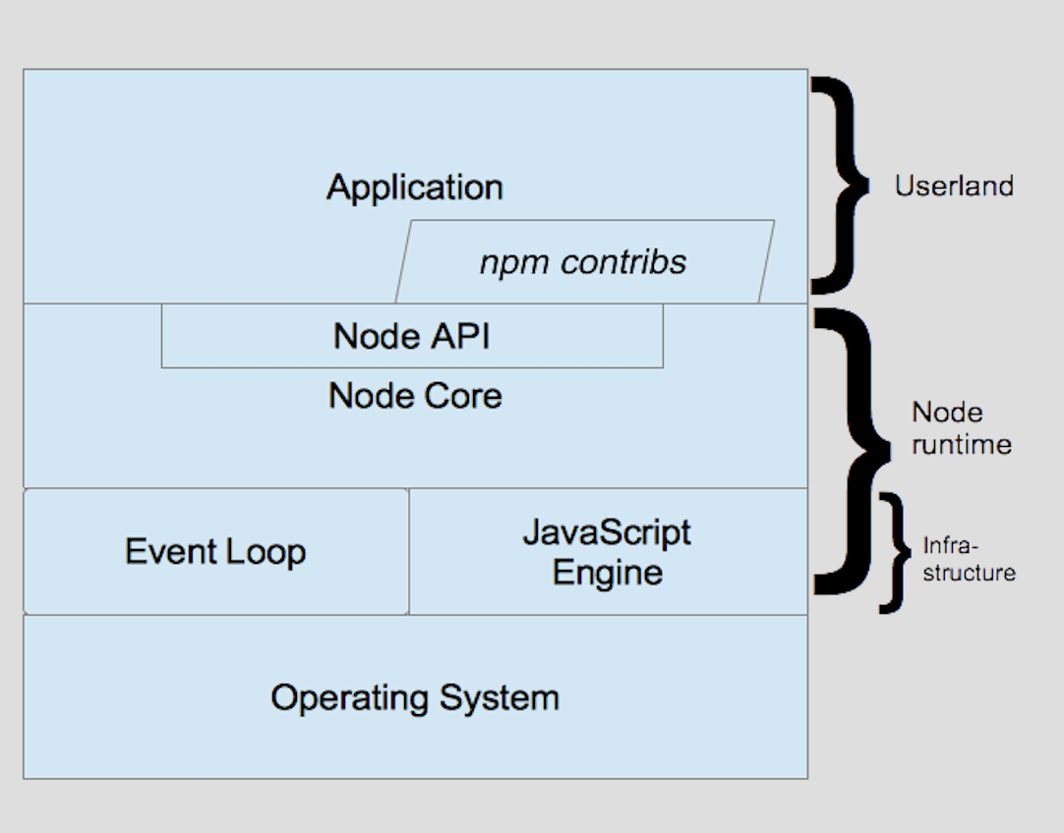

Figure 1. 1 The Node.js architecture stack

**b, Infrastructure**

The Node runtime’s infrastructure is comprised of two major components:

* JavaScript engine: The JavaScript engine used by Node is Chrome’s V8 engine, which runs all of the JavaScript code.
* Event loop: The event loop consists of various phases where callbacks are invoked:
* Timers phase: setInterval() and setTimeout() expired timer callbacks are run
* Poll phase: The OS is polled to see if any I/O operations are complete, and, if so, those callbacks are run
* Check phase: setImmediate() callbacks are run

### Features

1. *Modularity*

Major advantage of Node JS Platform is that it’s modularity [1]. Each and every functionality is divided and implemented as a separate module or package.

1. *Non-blocking or Asynchronous IO*

Asynchronous event-driven IO helps concurrent request handling – This is probably the biggest selling points of Node.js [1]. This feature basically means that if a request is received by Node for some Input/Output operation, it will execute the operation in the background and continue with processing other requests.

1. *Single Threaded but Highly Scalable*

Node.js uses a single threaded model with event looping [1]. Event mechanism helps the server to respond in a non-blocking way and makes the server highly scalable as opposed to traditional servers which create limited threads to handle requests. Node.js uses a single threaded program and the same program can provide service to a much larger number of requests than traditional servers like Apache HTTP Server.

1. *Better Socket API*

Node JS Platform provides very good Socket Module API to develop Real-time, Multi-User Chat and Multi-Player Gaming Applications very easily. It supports Unix Socket programming like pipe().

## MySQL

### Introduction

MySQL, the most popular Open Source SQL database management system, is developed, distributed, and supported by Oracle Corporation [2].

* **MySQL is a database management system:** a database is a structured collection of data [2]. It may be anything from a simple shopping list to a picture gallery or the vast amounts of information in a corporate network.
* **MySQL databases are relational:** a relational database stores data in separate tables rather than putting all the data in one big storeroom [2]. The database structures are organized into physical files optimized for speed. The logical model, with objects such as databases, tables, views, rows, and columns, offers a flexible programming environment.
* **MySQL software is Open Source:**  anybody can download the MySQL software from the Internet and use it without paying anything [2]. The source code can change it to suit user needs.
* **The MySQL Database Server is very fast, reliable, scalable, and easy to use**: MySQL Server can run comfortably on a desktop or laptop, alongside other applications, web servers, and so on, requiring little or no attention [2]. MySQL can also scale up to clusters of machines, networked together.

MySQL Server was originally developed to handle large databases much faster than existing solutions and has been successfully used in highly demanding production environments for several years [2]. Although under constant development, MySQL Server today offers a rich and useful set of functions. Its connectivity, speed, and security make MySQL Server highly suited for accessing databases on the Internet.

* **MySQL Server works in client/server or embedded systems:** The MySQL Database Software is a client/server system that consists of a multi-threaded SQL server that supports different back ends [2], several different client programs and libraries, administrative tools, and a wide range of application programming interfaces (APIs).
* **A large amount of contributed MySQL software is available.**

### MySQL Workbench:

MySQL Workbench is a graphical tool for working with MySQL servers and databases [3].

MySQL Workbench functionality covers five main topics:

* **SQL Development**: Enables to create and manage connections to database servers. Along with enabling to configure connection parameters [3], MySQL Workbench provides the capability to execute SQL queries on the database connections using the built-in SQL Editor.
* **Data Modeling (Design)**: Enables to create models of database schema graphically, reverse and forward engineer between a schema and a live database, and edit all aspects of database using the comprehensive Table Editor [3].
* **Server Administration**: Enables to administer MySQL server instances by administering users, performing backup and recovery, inspecting audit data, viewing database health, and monitoring the MySQL server performance [3].
* **Data Migration**: Allows to migrate from Microsoft SQL Server, Microsoft Access, Sybase ASE, SQLite, SQL Anywhere, PostgreSQL, and other RDBMS tables, objects, and data to MySQL [3].
* **MySQL Enterprise Support**: Support for Enterprise products such as MySQL Enterprise Backup, MySQL Firewall, and MySQL Audit [3].

## Firebase Real-time Database

### Introduction

Firebase Real-time database is a cloud-hosted database that supports multiple platforms Android, iOS and Web [4]. All the data is stored in JSON format and any changes in data reflect immediately by performing sync across all the platforms & devices.

**a, How the Data is Stored – JSON Structured**

Firebase real-time database is a schemaless database in which the data is stored in JSON format. Basically, the entire database is a big JSON tree with multiple nodes [4].

**b, Offline Data**

Firebase provides great support when comes to offline data. It automatically stores the data offline when there is no internet connection [4]. When the device connects to the internet, all the data will be pushed to the real-time database. However, enabling disk persistence stores the data offline even though app restarts. Disk persistence can be enabled by calling below one line code.

**c, Security & Rules**

Firebase rules provide a way to identify user role while performing read and write operations [4]. These rules will acts as a security layer on the server before perform any CRUD operation. By default the rules allow a user to perform read & write operation only after authentication.

Firebase Services can be divided into two groups, it’s shown in Figure 1.2 [1.2].

Figure 1. 2 Firebase Overview

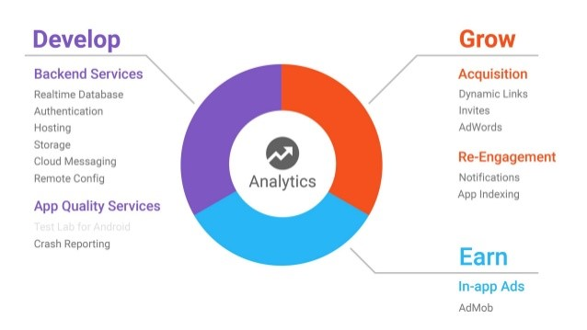

### Key capabilities:

* **Realtime**: Instead of typical HTTP requests, the Firebase Realtime Database uses data synchronization—every time data changes, any connected device receives that update within milliseconds [4]. Provide collaborative and immersive experiences without thinking about networking code.
* **Offline:** Firebase apps remain responsive even when offline because the Firebase Realtime Database SDK persists your data to disk [4]. Once connectivity is reestablished, the client device receives any changes it missed, synchronizing it with the current server state.
* **Accessible from Client Devices:** The Firebase Realtime Database can be accessed directly from a mobile device or web browser; there’s no need for an application server [4]. Security and data validation are available through the Firebase Realtime Database Security Rules, expression-based rules that are executed when data is read or written.
* **Scale across multiple databases:** With Firebase Realtime Database on the Blaze pricing plan, you can support your app's data needs at scale by splitting your data across multiple database instances in the same Firebase project [4]. Streamline authentication with Firebase Authentication on your project and authenticate users across your database instances. Control access to the data in each database with custom Firebase Realtime Database Rules for each database instance.

### Benefit

- Real-time Database is a cloud-hosted database [4]. Data is stored as JSON and synchronized continuously to each associated client.

- Hosting is production-grade web content that facilities the developers [4].

- Firebase Authentication gives backend services, simple to-use SDKs, and instant UI libraries to confirm clients over your application [4]. It supports authentication using passwords, email id or username.

- Firebase notification is a free service which allows targeted user notifications for mobile app developers [4]. It has the notification console GUI where you can create and send notifications to targeted users.

- This feature is used to index application in Google search results [4].

- Admob is advertising facility of the Firebase which is used to generate profits from your app [4].

## Angular Framework

### Introduction

Angular is a platform that makes it easy to build applications with the web [5]. Angular combines declarative templates, dependency injection, end to end tooling, and integrated best practices to solve development challenges. Angular empowers developers to build applications that live on the web, mobile, or the desktop.

### Architecture overview

The basic building blocks of an Angular application are NgModules, which provide a compilation context for components [5]. NgModules collect related code into functional sets; an Angular app is defined by a set of NgModules. An app always has at least a root module that enables bootstrapping, and typically has many more feature modules.

* Components define views, which are sets of site elements that Angular can choose among and modify according to your program logic and data.
* Components use services, which provide specific functionality not directly related to views. Service providers can be injected into components as dependencies, making your code modular, reusable, and efficient.

Both components and services are simply classes, with decorators that mark their type and provide metadata that tells Angular how to use them [5].

* The metadata for a component class associates it with a template that defines a view. A template combines ordinary HTML with Angular directives and binding markup that allow Angular to modify the HTML before rendering it for display.
* The metadata for a service class provides the information Angular needs to make it available to components through dependency injection (DI).

An app's components typically define many views, arranged hierarchically [5]. Angular provides the Router service to help you define navigation paths among views. The router provides sophisticated in-browser navigational capabilities.

The diagram shown in figure 1.3 describes how these basic pieces are related.

Figure 1. 3 Diagram of the relationship of the main building blocks



### Main building blocks

1. *Modules*

Angular NgModules differ from and complement JavaScript modules [5]. An NgModule declares a compilation context for a set of components that is dedicated to an application domain, a workflow, or a closely related set of capabilities. An NgModule can associate its components with related code, such as services, to form functional units.

Every Angular app has a root module, conventionally named AppModule, which provides the bootstrap mechanism that launches the application [5]. An app typically contains many functional modules.

1. *Components*

Every Angular application has at least one component, the root component that connects a component hierarchy with the page document object model (DOM). Each component defines a class that contains application data and logic, and is associated with an HTML template that defines a view to be displayed in a target environment [5].

The @Component() decorator identifies the class immediately below it as a component, and provides the template and related component-specific metadata.

1. *Templates, directives, and data binding*

A template combines HTML with Angular markup that can modify HTML elements before they are displayed. Template directives provide program logic, and binding markup connects your application data and the DOM [5]. There are two types of data binding:

* Event binding lets app respond to user input in the target environment by updating application data.
* Property binding lets interpolate values that are computed from application data into the HTML.

1. *Services and dependency injection*

For data or logic that isn't associated with a specific view, and that you want to share across components, you create a service class [5]. A service class definition is immediately preceded by the @Injectable() decorator.

Dependency injection (DI) lets you keep your component classes lean and efficient. They don't fetch data from the server, validate user input, or log directly to the console; they delegate such tasks to services.

1. *Routing*

The Angular Router NgModule provides a service that let's define a navigation path among the different application states and view hierarchies in the app [5]. It is modeled on the familiar browser navigation conventions:

* Enter a URL in the address bar and the browser navigates to a corresponding page.
* Click links on the page and the browser navigates to a new page.
* Click the browser's back and forward buttons and the browser navigates backward and forward through the history of pages you've seen.

### Benefit

- **Develop across all PlatForms:** Learn one way to build applications with Angular and reuse your code and abilities to build apps for any deployment target. For web, mobile web, native mobile and native desktop.

- **Speed and performance:** Achieve the maximum speed possible on the Web Platform today, and take it further, via Web Workers and server-side rendering. Angular puts in control over scalability. Meet huge data requirements by building data models on RxJS, Immutable.js or another push-model.

- **Incredible tooling:** Build features quickly with simple, declarative templates. Extend the template language and use a wide array of existing components. Get immediate Angular-specific help and feedback with nearly every IDE and editor.

- **Loved by millions:** From prototype through global deployment, Angular delivers the productivity and scalable infrastructure that supports Google's largest applications.

**1.5. Conclusion**

By studying and learning about the above technologies, we successfully applied the concepts and their mechanism operating in this project.

Some of these technologies are not new, but they are widely using and a trend for the software development industry. Therefore, understanding the concept is very important, help to apply properly technology for each project, in order to improve efficiency and usability.

We have introduced some technologies that we implemented in the project. In the next chapter, we will introduce the analysis and design section to describe more details about my system.

# Chapter 2: ANALYSIS AND DESIGN

## 2.1. Analysis main features

To clarify this web system, we have following features.

### Matches management

When the user login to the web system, the user can select “Manage Matches” feature on the top menu. On the site “Manage Matches” the user can click the button “Create new match” to create a new match. Once the user creates a new match, this one will show on the public home page. To update the information of a match, user can select action “Edit” on the site “Manage Matches”, user can change some fields and click “Update” button to update data.

### Gridirons management

In this part, when the user login to the web system, the user can select “Manage Gridirons” feature on the top menu. On the site “Manage Gridirons” the user can click the button “Create new gridiron” to create a new gridiron. Once the user creates a new gridiron, this one will show on the public gridirons page. To update the information of a gridiron, user can select action “Edit” on the site “Manage Gridirons”, user can change some fields and click “Update” button to update data.

Besides that, In the detail of gridiron site, the user can add the price for each gridiron to show to everyone.

### Leagues management

In this part, when the user login to the web system, the user can select “Manage Leagues” feature on the top menu. On the site “Manage Leagues” the user can click the button “Create new league” to create a new league. Once the user creates a new league, this one will show on the public leagues page. To update the information of a league, user can select action “Edit” on the site “Manage Leagues”, user can change some fields and click “Update” button to update data.

Besides that, when the user creates a new league, the system will generate schedule for the league. The user can update detail of every match such as score, time of competition, description of a match. Once the user updates the detail of the match, the system will auto update point, number of matches played, number of matches won, ...etc. and show the league's standings.

### Team management

In this part, when the user login to the web system, the user can select “Manage Teams” feature on the top menu. On the site “Manage Teams” the user can click the button “Create new team” to create a new team. To update the information of a team, user can select action “Edit” on the site “Manage Teams”, user can change some fields and click “Update” button to update data.

Besides that, In the detail of team site, the user can manage the team members such as add, remove, ...etc.

### Pairing matches

Once the other users create a new match, this one will show on the public home page. The user can search and view detail of those matches. The user can Pair Match with any matches, which has status is “New”. If the user wants to pair matches, the user has to have at least a team.

After the user gets the message “Pair match successfully”, the system generates a message to notifies the match creators. The match creators can “Confirm” or “Reject” the pairing request.

## Use case diagram

### Overall diagram

The web system includes these features:

* Manage and show areas (team, gridiron).
* Manage and show team’s career.
* Manage and show team’s level
* Manage and show the gridirons.
* Manage and show the teams.
* Manage and show the leagues.
* Manage and show the matches.
* Search matches, gridirons, leagues.

With these features above, the web system has three actors (the users, the guest and the admin) interacting with the system. The overall use-case is shown in the figure 2.1.

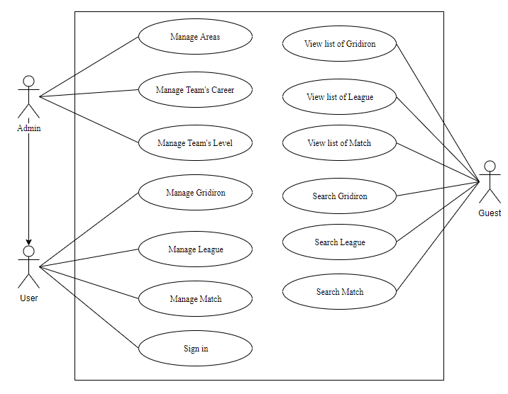

Figure 2. 1 Overall use case diagram

### Areas management

“Manage Areas” has following these features: View list, View detail, Create, Update, Delete.

If the user is admin then user can select “Manage Areas” feature on dropdown menu. In the detail of this feature, user can view the list, search, create, update and delete the area. The use-case for this feature is shown in the figure 2.2.

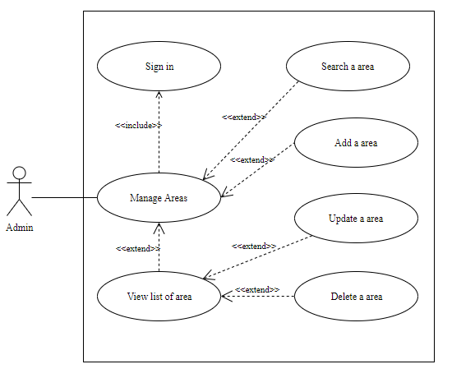

Figure 2. 2 Manage Areas use case diagram.

### Team careers management

“Manage Team’s Career” has following these features: View, Add, View Detail, Update, Delete.

If user is admin then the user can select “Manage Team’s Career” feature on dropdown menu. In the detail of this feature, user can view the list, search, create, update and delete the career. The use-case for this feature is shown in the figure 2.3.

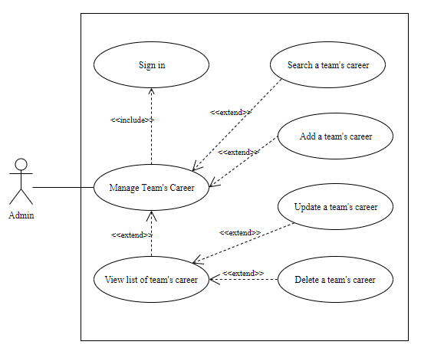

Figure 2. 3 Manage Team’s Career use case diagram.

### Team levels management

“Manage Team’s Level” has following these features: View, Add, View Detail, Update, Delete.

If user is admin then the user can select “Manage Team’s Level” feature on dropdown menu. In the detail of this feature, user can view the list, search, create, update and delete the team’s level. The use-case for this feature is shown in the figure 2.4.

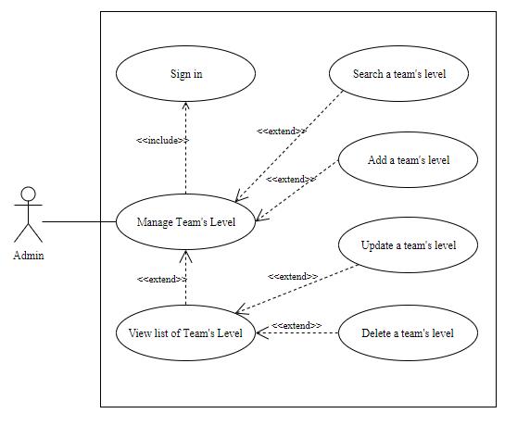

Figure 2. 4 Manage Team’s Level use case diagram.

### Gridiron management

“Manage Gridiron” has following these features: View, Add, View Detail, Update, Delete, manage the price of each gridiron.

The user can select “Manage Gridiron” feature on dropdown menu. In the detail of this feature, user can view the list, search, create, update and delete the gridiron.

Besides that, the user can create new sub-gridiron and the price of each gridiron. The use-case for this feature is shown in the figure 2.5.

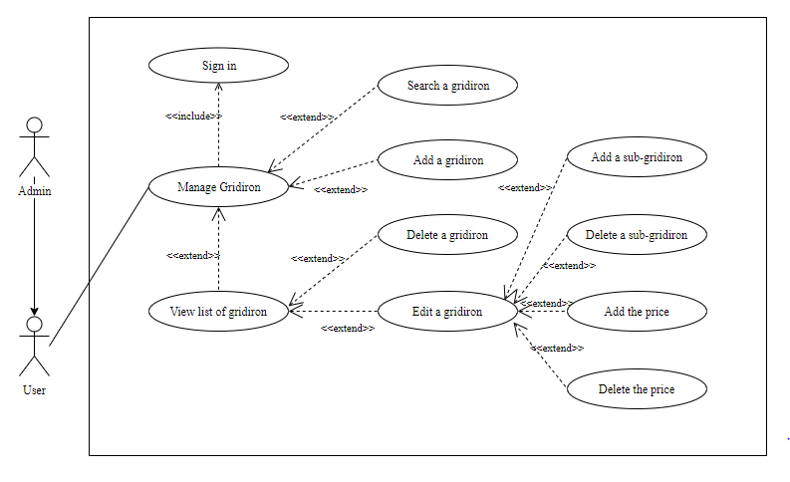

Figure 2. 5 Manage Gridirons use case diagram.

### League management

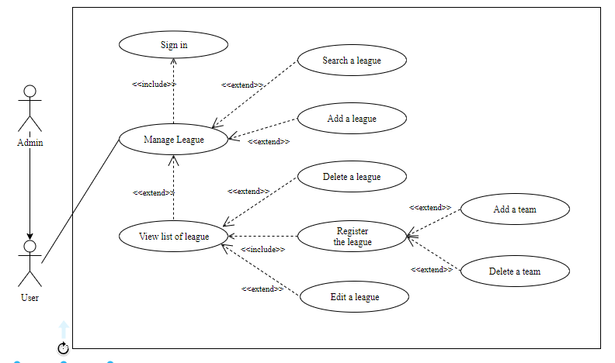

Figure 2. 6 Manage Leagues use case diagram.

The diagram shown in figure 2.6 describes the process “Manage Leagues”. “Manage Leagues” has following these features: View, Add, View Detail, Update, Manage the teams registered, Update the matches information of league.

The user can select “Manage Leagues” on the dropdown menu. In the detail of this feature, the user can view the list, search, create, update, manage teams registered and update the match’s information of the leagues.

### Matches management

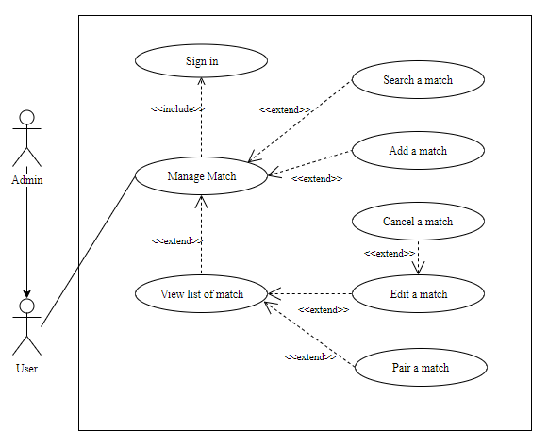

Figure 2. 7 Manage Matches use case diagram.

The diagram shown in figure 2.7 describes the process “Manage Matches”. “Manage Matches” has following these features: View, Add, View Detail, Update, Confirm or Reject request Pair Match of other teams.

The user can select “Manage Matches” feature on the dropdown menu. In the detail of this feature, user can view the list, search history matches, create, update, confirm or reject the request “pair match” of the other team.

## Activity Diagram

### 2.3.1. Register

The diagram shown in figure 2.8 describes the process in with user register a new account. User has to fill user’ information into the registration form. After that, the system checks automatically the user’s information. If the user’s information is valid then the system saves that information to the database and notifies successful message to the user.

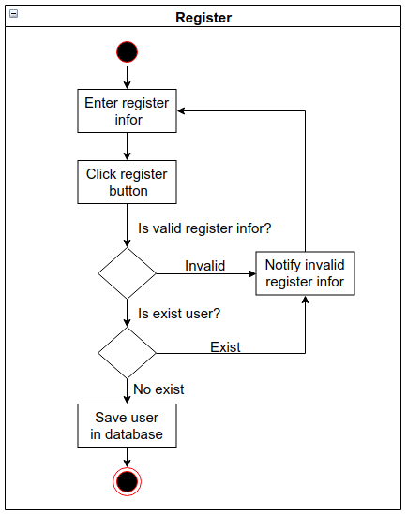

Figure 2. 8 Activity Register diagram

### 2.3.2. Log in

The diagram shown in figure 2.9 describes the process in with user sign in to the system. User has to fill user’s information into the login form. After that, the system calls API to check automatically the user’s information. If the user’s information is valid then the system saves that information to the Local Storage and navigates to home page.

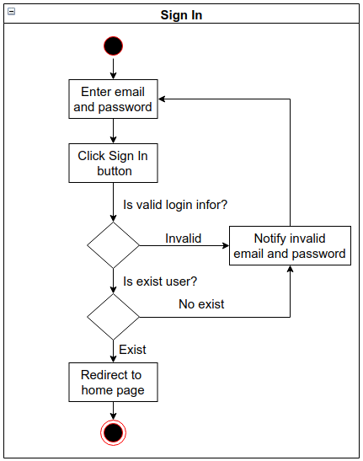

Figure 2. 9 Activity Sign In diagram

***2.3.3. Matches create***

The diagram shown in figure 2.10 describes the process in with user create new match. User has to fill match’s information into the “Create match” form. After that, the system calls API to check automatically the match’s information. If the match’s information is valid then the system saves that information to the database and notifies successful message to the user.

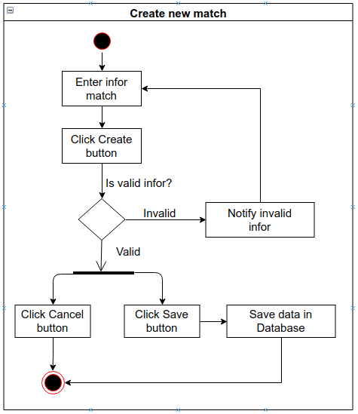

Figure 2. 10 Activity create new match diagram

***2.3.4. Matches update***

The diagram shown in figure 2.11 describes the process in with user update match. User change some information in the “Update match” form. After that, the system calls API to check automatically the match’s information. If the match’s information is valid then the system saves that information to the database and notifies successful message to the user.

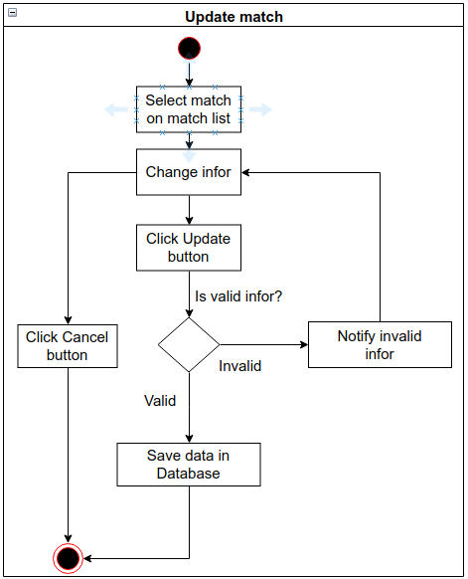

Figure 2. 11 Activity update match diagram

***2.3.5. Pair match***

The diagram shown in figure 2.12 describes the process in with user pair match with another team. The user has to select the team to pair match then click “Pair” button. After that, the system calls API to check automatically the team's information. If the team’s information is valid then the system updates the match's information to the database and notifies successful message to the user.

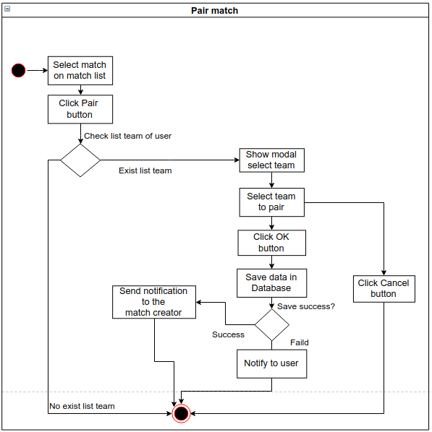

Figure 2. 12 Activity Pair Match diagram

## Interraction diagram

### Register Account

The user has to fill account’s information then the system will check to validate request and call restful API to controller, after that, Modal connects to MYSQL and saves data in the database then notifies to user. The sequence diagram for this feature is shown in the figure 2.13.

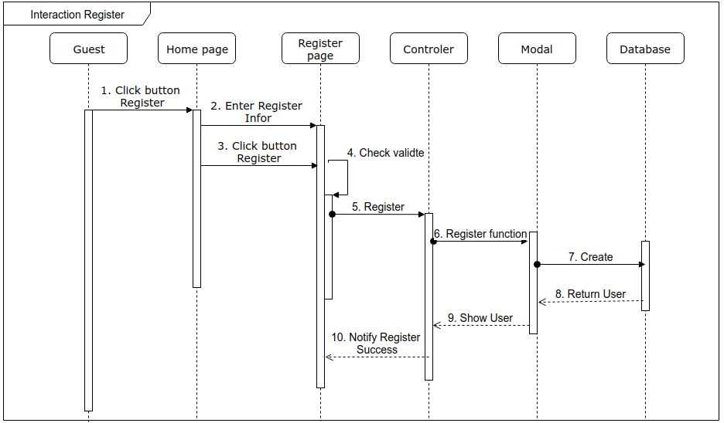

Figure 2. 13 Sequence diagram register

### https://lh4.googleusercontent.com/c4IzH2HE8tYfI6ADm84-IorrZ8D_ZKZ6m0ppuzOQ2jhmEiw00EZH-s5XiCUpgnigB0eqjrnXaQYmeNJ8jX2C8jyDWueUnUY0wli0rYkNBaN0IQyR_Wg-Hq5tS4wdtQLogin

Figure 2. 14 The sequence diagram for login feature

The diagram shown in figure 2.14 describes the sequence diagram for login feature. The user has to fill account’s information then the system will check to validate request and call restful API to controller, after that, Modal connects to MYSQL and checks data in the database then notifies to user.

### Create Match

The user has to fill match’s information then the system will check to validate request and call restful API to Controller, after that, Modal connects to MYSQL and save data in the database then notifies to user. The sequence diagram for this feature is shown in the figure 2.15.

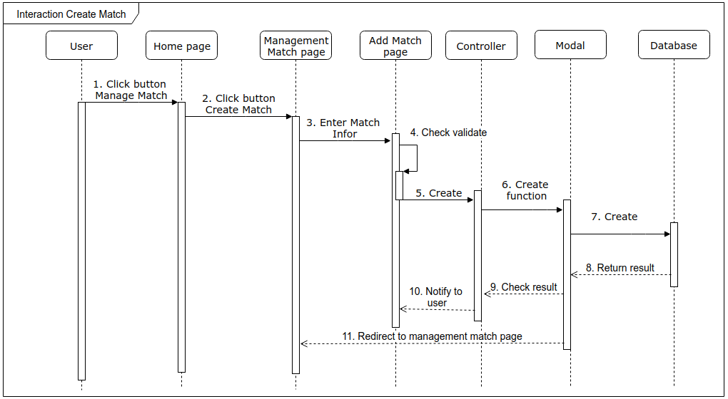

Figure 2. 15 The sequence diagram for create matches

### Pair Match

The user has to select a team to pair a suitable football match, then the system will call restful API to Controller. After that, Modal connect to MYSQL and updates match's information in the database. Once data was saved to the database, the system generates a new notification and save to database. After that, the system sends to the match creators and notifies to the user. The sequence diagram for this feature is shown in figure 2.16.

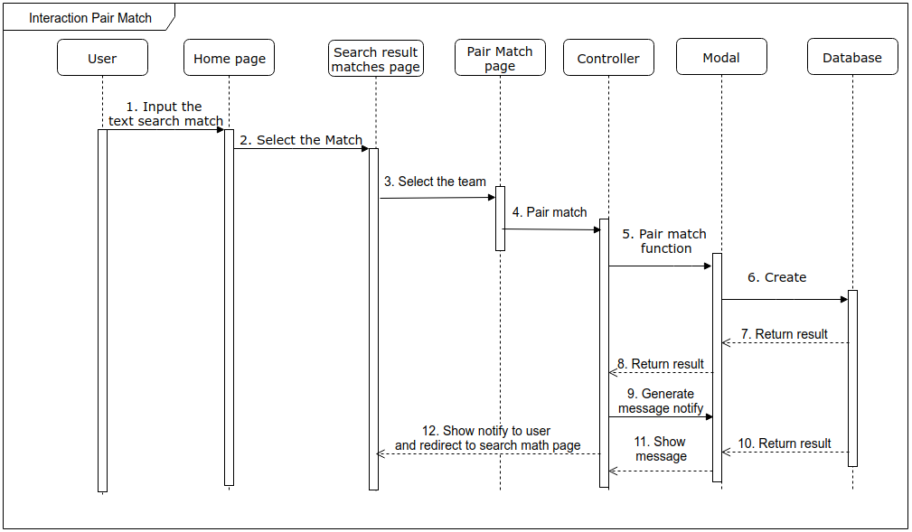

Figure 2. 16 The sequence for pair matches feature

## Basic ERD

Simple entity-relationship diagram of the system shows the relationships of entity sets stored in a database. An entity in this context is an object, a component of data. The basic ERD is shown in figure 2.17.

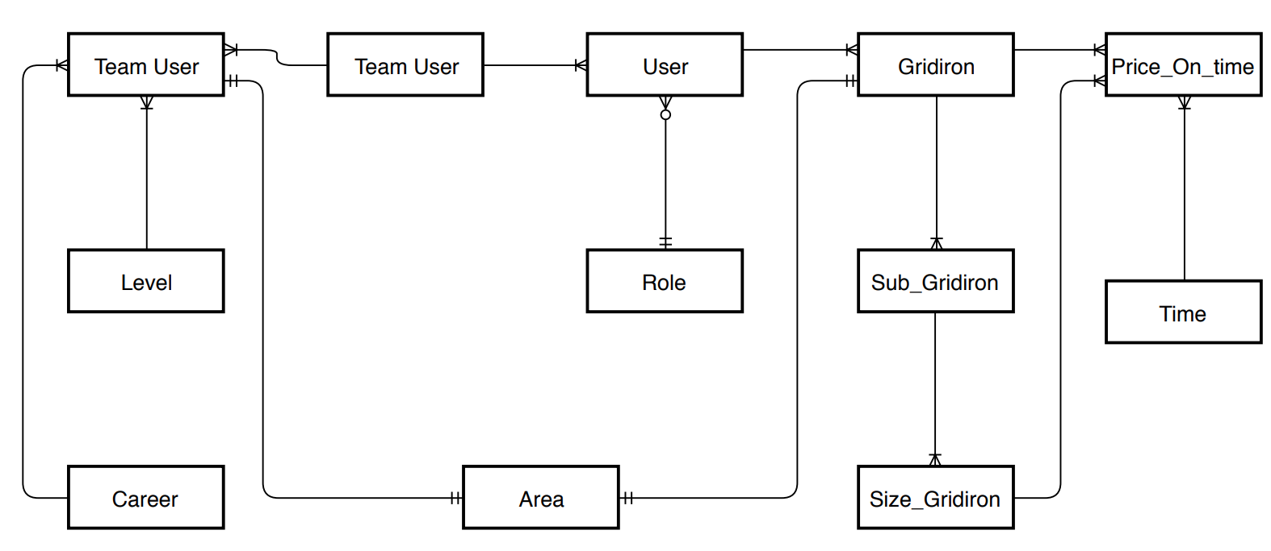

Figure 2. 17 Simple entity-relationship diagram of the system.

## Class diagram

The diagram shown in figure 2.18 describes the detail information of the entities in the application. It includes details fields of each entity and relationship.

The role of the user, admin permissions by view-page. Admin has permission setting type of user and all view-page this one can access.

In short, the diagram describes the basic class and the relationship of the system, we will talk about this more detail in the design section.

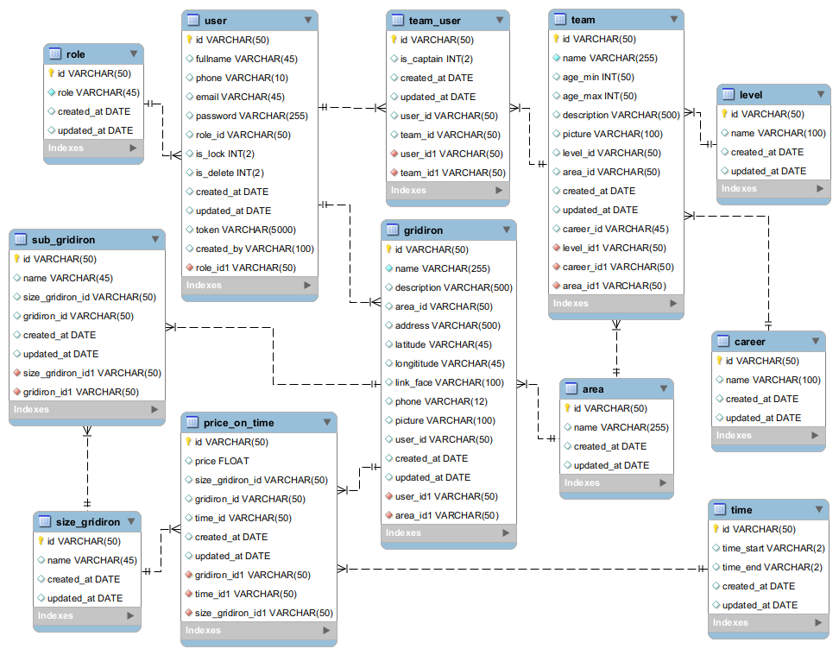The class diagram is shown in figure 2.18.

Figure 2. Class diagram

## Conclusion

This chapter introduced the analysis and design of the system supporting football teams. The system includes functions like as Manage the teams, Manage the matches, Manage the leagues, Manage the gridirons, … In the next chapter, we introduce performance of the designed system.

# Chapter 3: IMPLEMENTATION RESULTS

This chapter, we will talk about the implementation results.

**3.1. Login function**

Normally, users who do not need to log in to the system will still be able to search for gridirons information, matches, and tournaments.

To use functions such as managing matches, gridirons, users need to log into the system. The interface of the login function is shown in the figure 3.1.

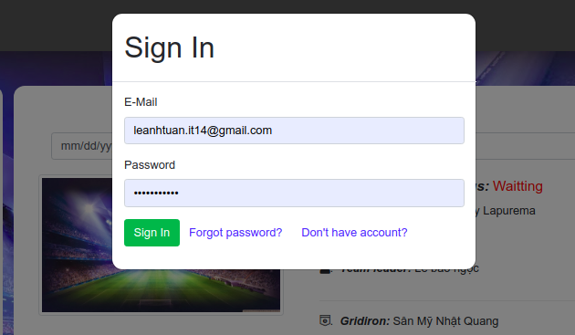

Figure 3. 1 Login page

**3.2. Register function**

If users do not login to the system, users just use some features such as search the gridirons, the matches, the leagues.

User can register new account to login to the system. The interface of the register function is shown in the figure 3.2.

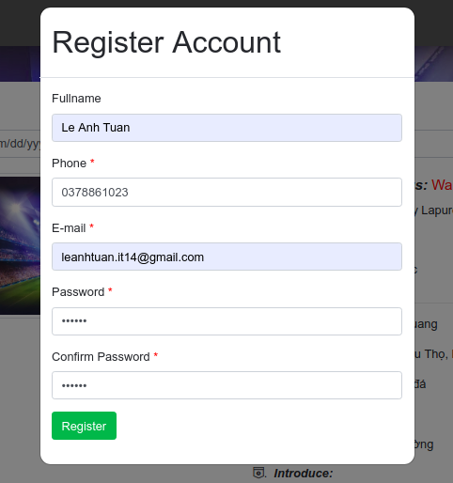

Figure 3. 2 Register page

**3.3. Reset Password function**

If users lost their password, users can reset it. Users type the email then the system will reset and send a new password to the user’s email. The interface of the reset password function is shown in the figures (3.3, 3.4).

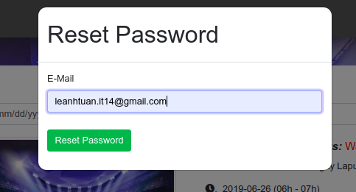

Figure 3. 3 Reset password page

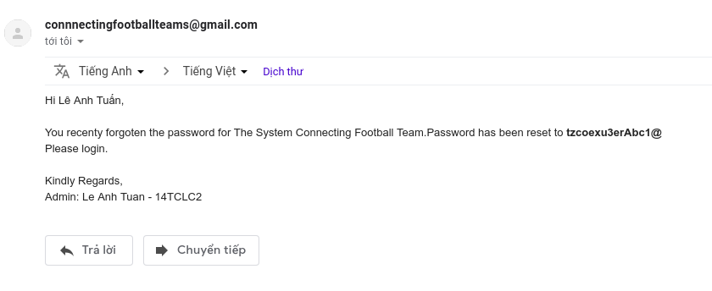

Figure 3. 4 Got email reset password

**3.4. Matches management**

“Manage Matches” feature requires users to log in to the system. The list of history matches, the interface for update information, “Create new match” are shown in the figures (3.5, 3.6, 3.7).

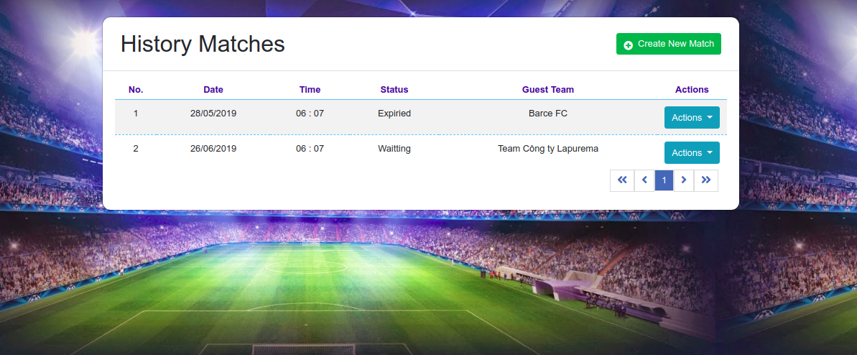

Figure 3. 5. Show list of match page

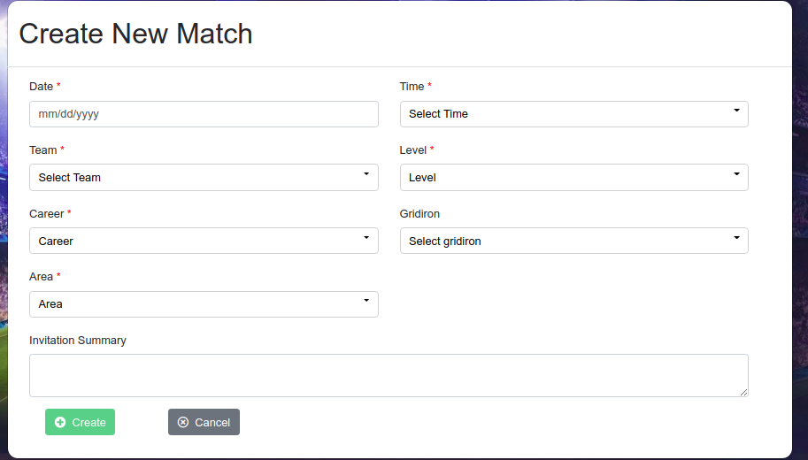

Figure 3. 6. The interface for creating new match

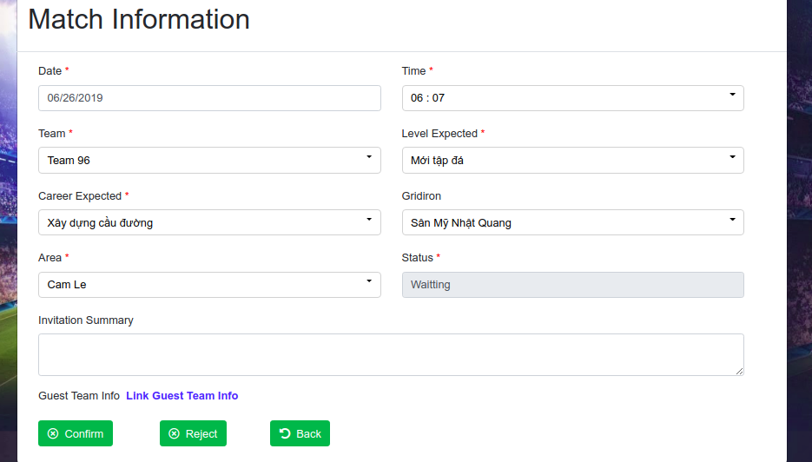

Figure 3. 7. The interface for updating match information

**3.5. Leagues management**

“Manage Leagues" feature requires users to log in to the system. “Manage Leagues” feature has some following interfaces.

The user’s leagues shown in the figure 3.8.

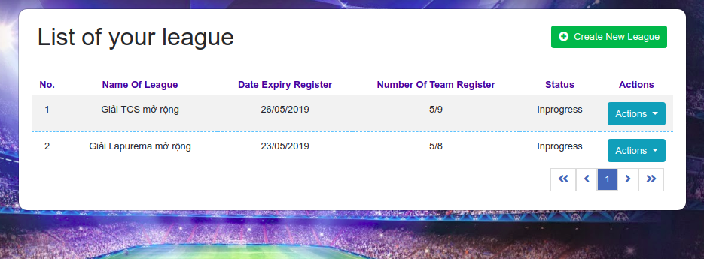

Figure 3. 8. Show list of leagues

The interface for creating new league function is shown in the figure 3.9.

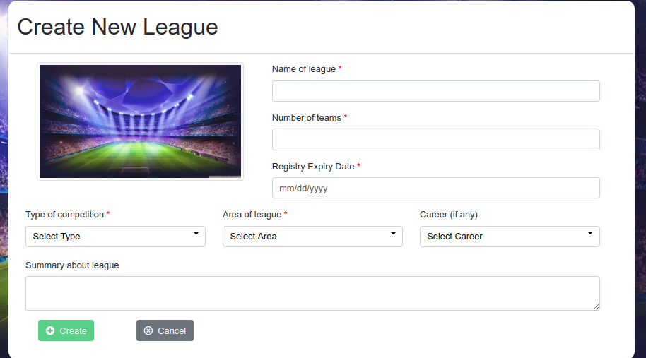

Figure 3. 9. The interface for creating league

The interface for updating league information function is shown in the figure 3.10.

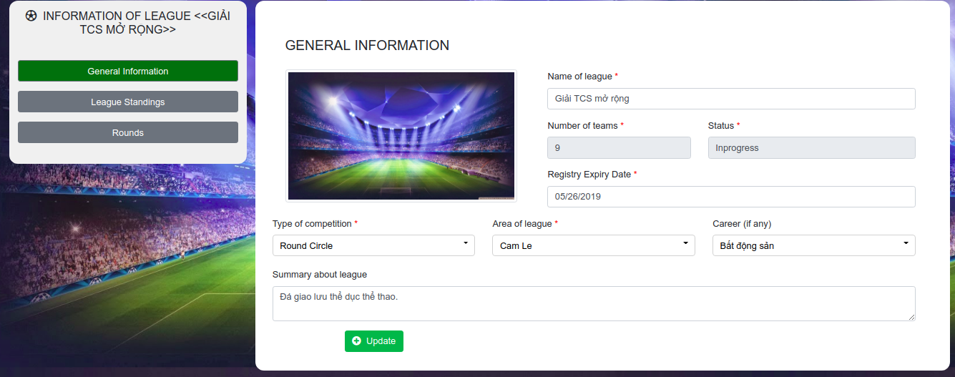

Figure 3. 10. The interface for update league information

The list standings of teams shown in the figure 3.11.

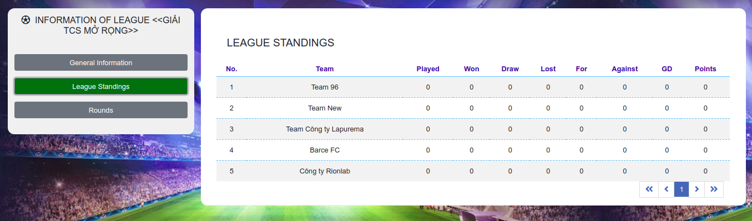

Figure 3. 11. List standings of teams in the league

Rounds of the league is shown in the figure 3.12.

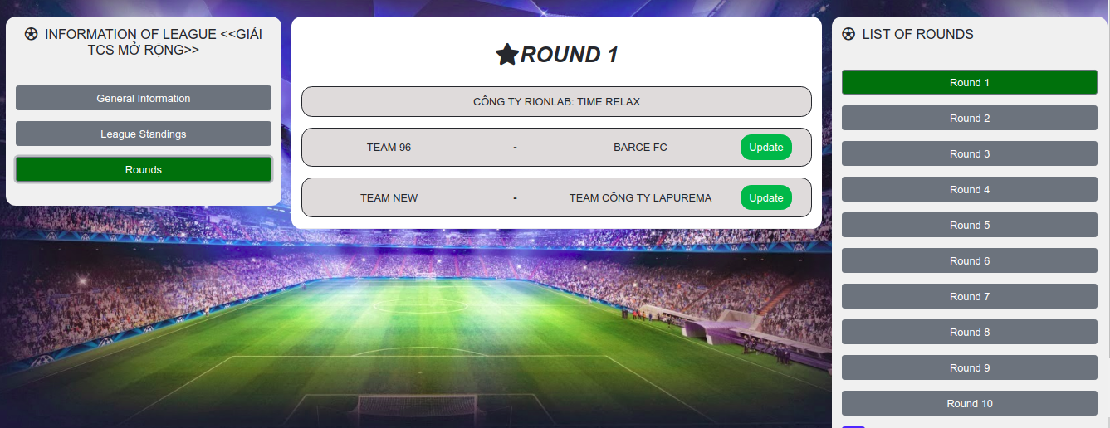

Figure 3. 12. List rounds of the league

The interface for updating matches information of the league is shown in the figure 3.13.

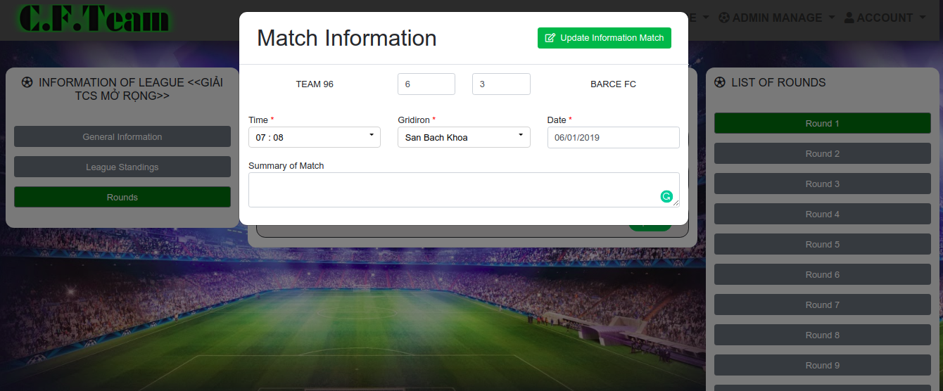

Figure 3. 13. The interface update matches of the league

**3.6. Gridirons management**

“Manage Gridirons” feature requires users to log in to the system. “Manage Gridirons” feature has some following interfaces. The user’s list of gridirons shown in figure 3.14.

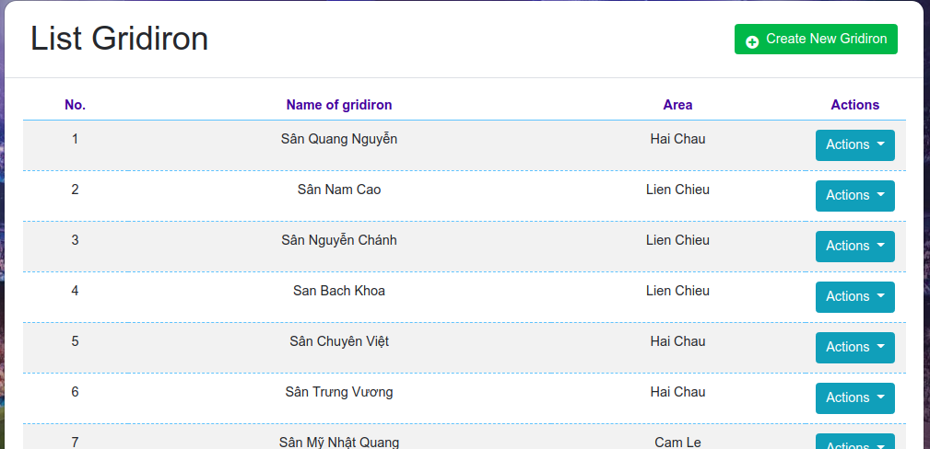

Figure 3. 14. Show list of gridirons

The interface for creating gridirons is shown in the figure 3.15.

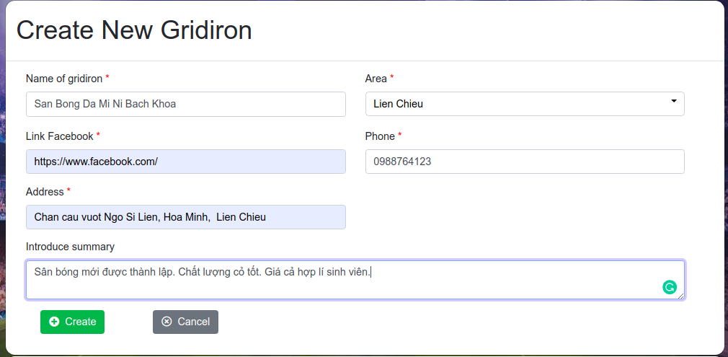

Figure 3. 15. The interface for creating gridiron

The interface for updating gridirons is shown in the figure 3.16.

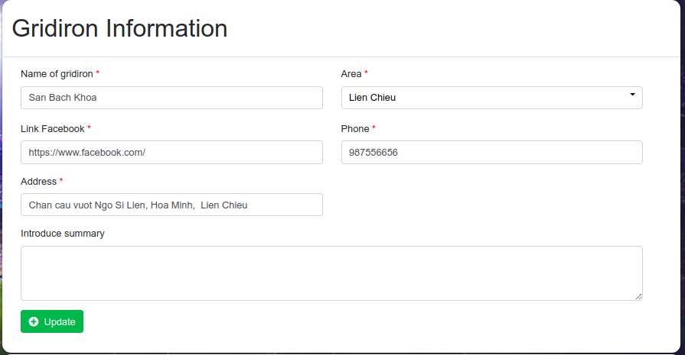

Figure 3. 16. The interface for updating gridiron

The interface for creating sub-gridirons is shown in the figure 3.17.

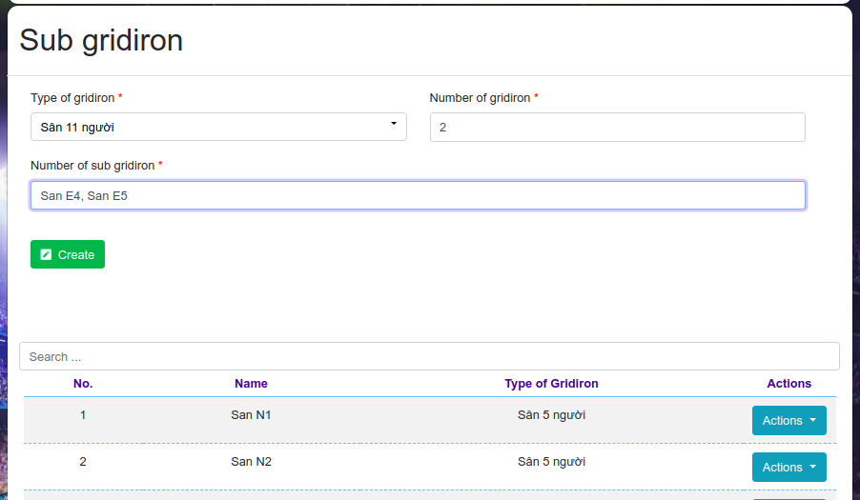

Figure 3. 17. The interface for creating sub-gridiron

The interface for creating the price of gridirons is shown in the figure 3.18.

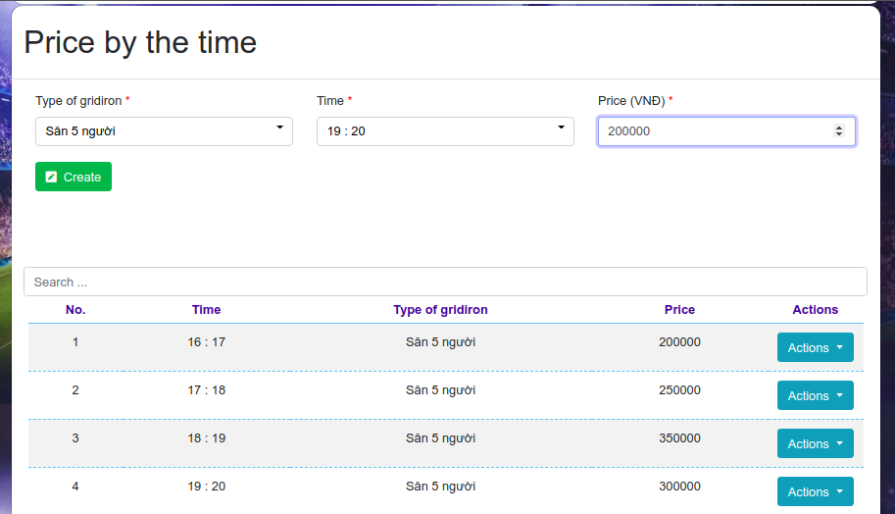

Figure 3. 18. The interface for creating the price of gridiron

**3.7. Teams management**

“Manage Teams” feature requires users to log in to the system. “Manage Teams” feature has some following interfaces.

The user’s list of teams shown in the figure 3.19.

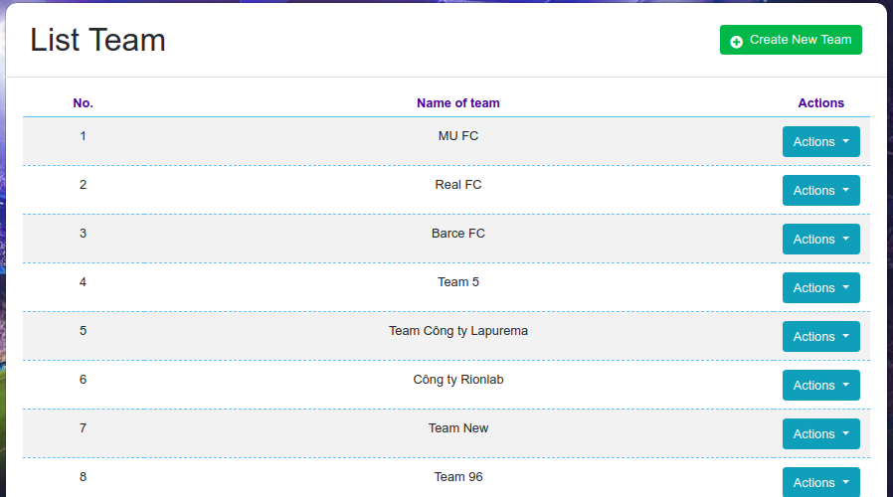

Figure 3. 19. Show list of teams

The interface for creating team is shown in the figure 3.20.

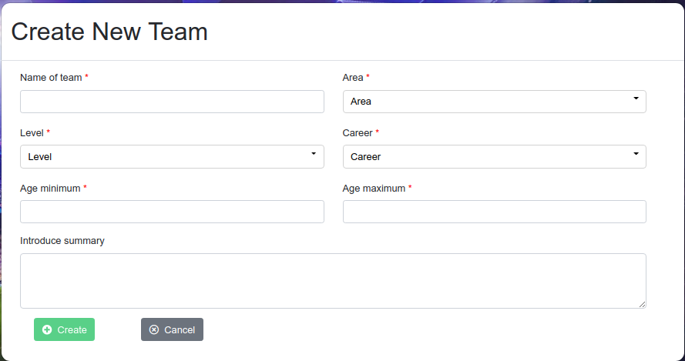

Figure 3. 20. The interface for creating team

The interface for updating team is shown in the figure 3.21.

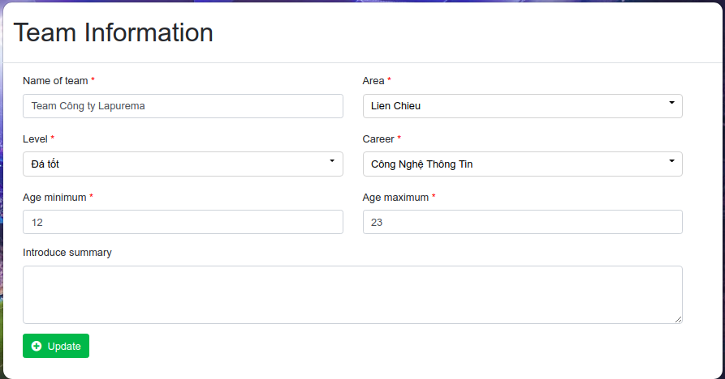

Figure 3. 21. The interface for updating team

The interface for adding new member to the team is shown in the figure 3.22.

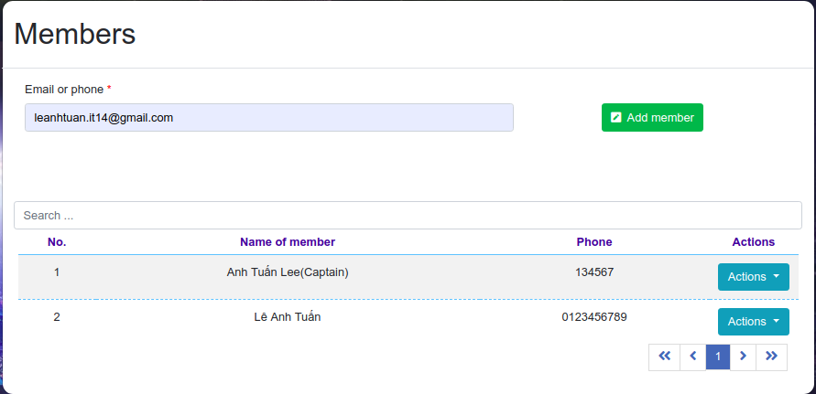

Figure 3. 22. The interface for adding new member to the team

**3.8. Pairing Match**

On the “Public home page” site users can select “Pair” then select team to pair the match (figure 3.23).

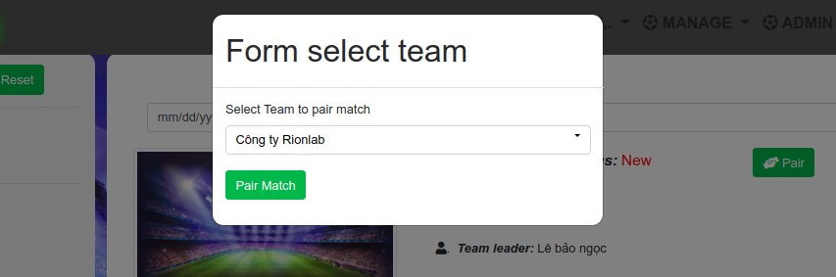

Figure 3. 23. The interface for pairing match

Once the user pair match successfully, the system generates a notification and send to the match creator. this feature is shown in the figures 3.24.



Figure 3. 24 Show full list notification

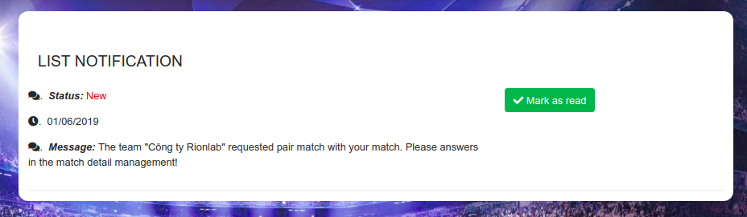

Figure 3. 25. Show full list notification

**3.9. Confirm, Reject Matches**

On the detail of site “Manage Matches”, the user can confirm or reject the requested pair match. this feature is shown in the figure 3.25.

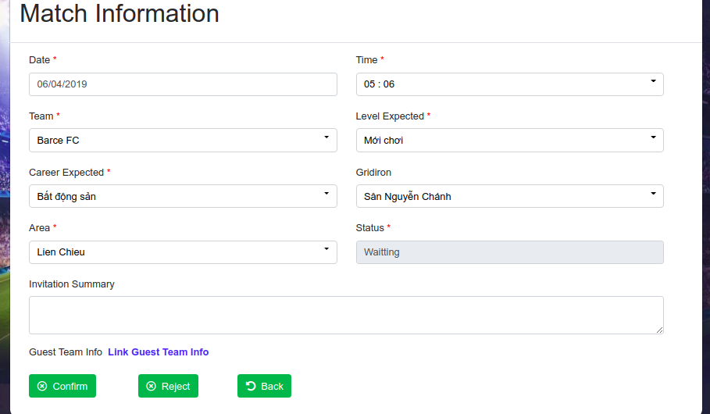

Figure 3. 26. The interface for function confirms or reject match

Once confirm or reject the requested pair match, the system will auto generate a notification and send to the requester. this feature is shown in the figures 3.26.

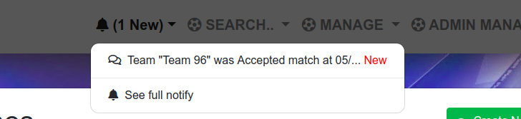

Figure 3. 27 Show message confirmed request

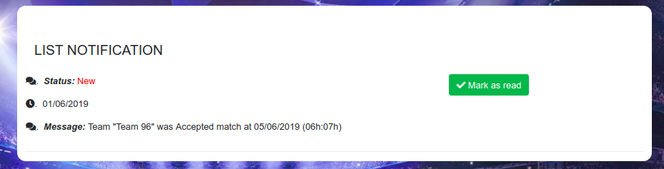

Figure 3. 28. Show full list of notification

**3.10. Register join league**

On the “Public league page” site users can select “Register” then select team to register to join the league. This feature is shown in the figure 3.27.

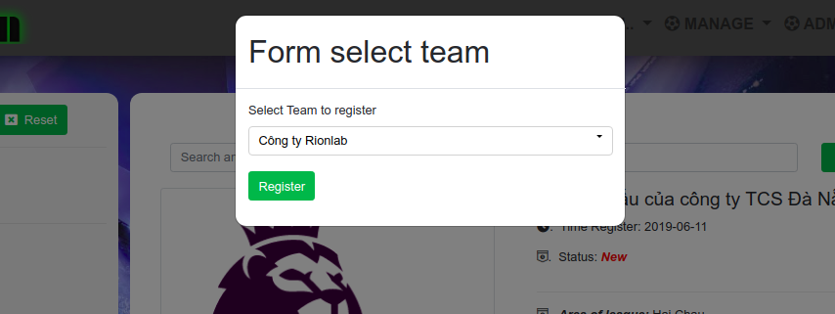

Figure 3. 29. The interface for registering to join league function

Once register successfully, the user can check in the detail of league as the figure 3.28.

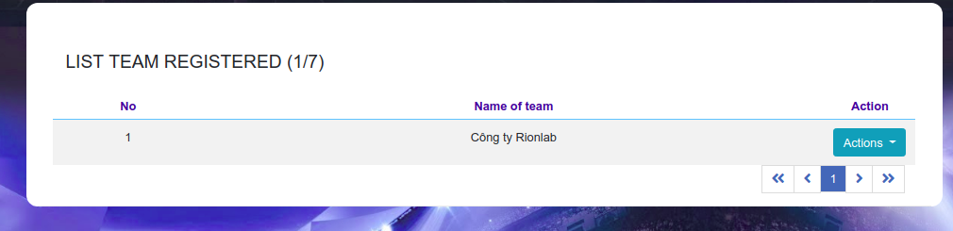

Figure 3. 30. Show list of teams registered to join league

**3.11. Home page**

The figure 3.31 shown “Public matches page” of the system which the user can search the matches and pair the matches.

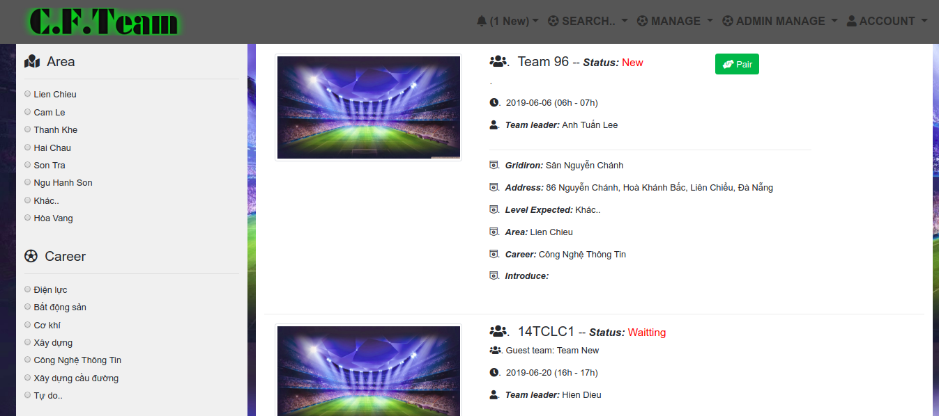

Figure 3. 31 Public matches page

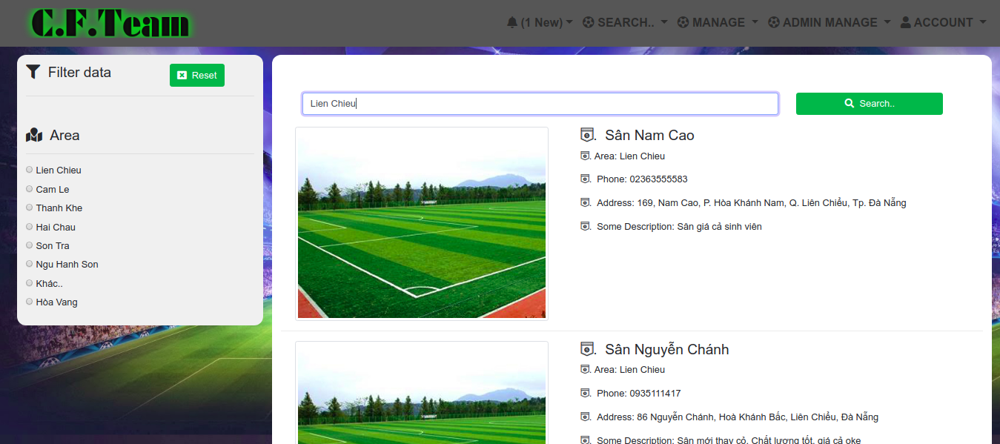

Figure 3. 32 Public gridirons page

Figure 3.32 above shown “Public gridirons page” of the system which the user can search then view detail of the gridiron.

Figure 3.33 shown “Public leagues page” of the system which the user can search then view detail or register to join.

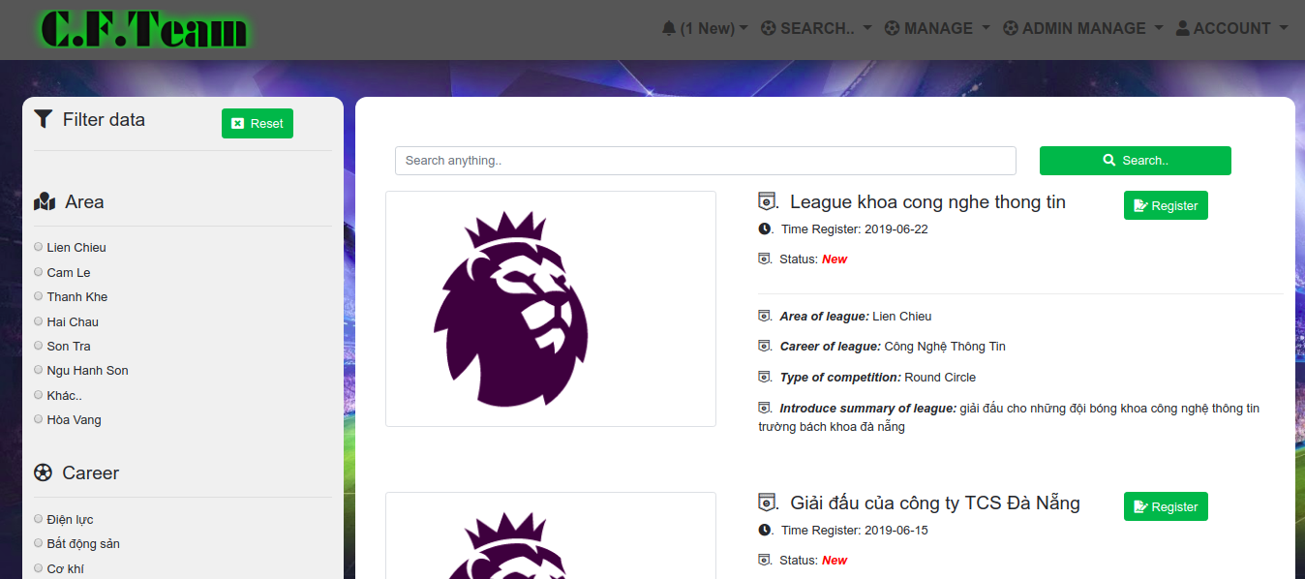

Figure 3. 33 Public leagues page

# CONCLUSION AND FUTURE WORK

## Achieve results

In this project, we have been learning JavaScript language and can understand how to work with Node JS Platform. We use JavaScript to program asynchronously with Node JS Platform to build the API server. We use the Angular framework to build the application. We use the MYSQL and Firebase database to store our database. We also improved researching skill, technical skill, presentation skill, English skill and other soft skills when we build this project.

With gained bits of knowledge, we built the graduation project satisfying initial requirements with following achievements:

* The system supports user to manage the gridirons, the teams, the leagues, the team’s level, the team’s career, the matches and the areas.
* The system can support user to generate the schedule of leagues, pair match with other teams, notify to the user when the request pairing match is confirmed or rejected.

However, with advantages, this web system still has following foibles:

* The user just can search the gridirons at Da Nang city but cannot track which the gridirons are empty.
* The system cannot support for the user to book the gridirons on the internet.
* The system cannot support to send a message to the user’s phone when the system receives the request to pair match.

## Future works

With the disadvantages which are mentioned above. In the future we will develop some following features:

* Supporting the user to book the gridirons on the internet.
* To send the message to the user’s phone to notify if the system receives the request to book gridirons or to pair matches.
* Supporting the user to track the gridirons which are available or not.

# REFERENCES

[1] Nodejs documentation. Available on website: <https://nodejs.org/>

[1.1] The image is available on website: <https://developer.ibm.com/tutorials/learn-nodejs-tour-node/>

[1.2] The image is available on website: <https://www.slideshare.net/danielsju6/iosdevcamp-firebase-overview>

[2] MySQL Server documentation available on website: <https://dev.mysql.com/doc/refman/8.0/en/>

[3] MySQL Workbench documentation available on website: <https://dev.mysql.com/doc/workbench/en/>

[4] Firebase database documentation available on website: <https://firebase.google.com/docs/database>

[5] Angular framework documentation available on website: <https://angular.io/docs>

[6] React-native framework documentation available on website: <https://facebook.github.io/react-native/docs/getting-started.html>

[7] React-native architecture documentation available on website: <https://www.reactnative.guide/3-react-native-internals/3.1-react-native-internals.html>